

Intranet Redesign

Carlos Carbajal, Chao Zhu, Song Zhang, Han Kim

CIS 440

Contents

Executive Summary 2

The Development Team 4

The Client/Contact 4

Functionality Overview 4

Technology Stack 6

Tech List: 6

Original Microchip Intranet 7

Customer Demand 8

Initial Mock-ups & Designs 8

Initial Mock-ups & Designs (cont.) 10

Meetings and Changes 11

User Guide 13

Code View 23

Test Results 28

Testing Results Summary 36

Whats Next 36

### Executive Summary

##### **The Client:**

Our client, Microchip Technology is an American based manufacturer of microcontroller, memory and analog semiconductors headquartered here in Chandler, Arizona. Microchip had close to 2 billion dollars in revenue last year, but despite its financial achievements their intranet that is used within their main corporate headquarters in Arizona was needed of drastic improvements.

##### **The Problem:**

In 2003, SharePoint was chosen to replace Lotus Notes as Microchip’s Intranet platform. The new Intranet site, Mchpweb, was introduced to the business users with modest beginnings as a simple portal that gave users access to different department sites and various service tools. As Microchip continued to grow in size, business unit, and function, more information was jumbled on existing pages, with the hope that providing a lot of different information would mean that something was relevant to someone. Not having a dedicated development team to release new and improved tools and the absence of an editorial group to provide relevant and current content information further hampered Mchpweb’s usability and user adoption. The intranet contained lots of redundant information, as well as useless information that was easy to find while some important information and features took some effort to locate in the unorganized intranet. Microchip requested that we create a whole new intranet design from scratch, make the appearance more attractive than its predecessor, and reduce down to the minimum on redundant information that was scattered all over the existing intranet.

##### **Proposed Solution:**

Since Microchip Technology is a large corporation with lots of sensitive information within it databases and systems, we were not able to get complete access to all the information required and necessary to completely overhaul the existing intranet to a new, more efficient intranet, so we proposed to create a new intranet design from scratch, which will have no redundant information, easy to navigate, more attractive and have just the certain important features and tools fully functional.

### The Development Team

* Scrum Master/Development Lead: Carlos Carbajal
* Development Team(Code): Chao Zhu
* Development Team(Code): Song Zhang
* Development Team(Misc.): Han Kim

### The Client/Contact

* Contact Person @ Microchip: Louise Tung

### Functionality Overview

* Our goal and the functionality required for this intranet is to have a completed design of the intranet with select few working links and functions.
* Conference room finder functionality which allows the user to look up a conference room and see where it is located on a company map
* MicroWiki Page functionality will allow users to go to a page to look up/add/edit acronyms used within Microchip
* World Clock functionality will be a tool which shows the user the time, different locations of Microchip and various other time related information such as time zones.
* Real time stock price system, shows the current stock price of Microchip, and also provide Fidelity, and ETrade links to user
* Calendar which contain work schedule, showing task with time, location, and participants.

### Technology Stack

In the beginning we were asked by the client to use a tool called “Sitefinity” but since the remote access granted by Microchip Technology was too slow for outside use, and the remote access service does not have Visual Studio which is the most important part of Sitefinity, we decided to use WordPress for the basis of our intranet design with some code changes/additions to add some of the necessary functionality.

Compare to Sitefinity, WordPress is more convenient to use, more flexible with html, php, and js (Sitefinity use .ASP framework, which requires to use .NET), and also, has more widgets and add-ins for us.

Here is the complete list of every technology and programs used in creating this intranet.

### **Tech List**:

Word Press: Content Management System

GoDaddy: Web Hosting

Media Wiki: Web application to build Microwiki

AJAX: For asynchronous transmission, provide instance response for search engine

CSS: To style the data

HTML: To store text information

MySQL: To Store all the acronyms concerning the Microwiki, and user information

JQuery: To use autocomplete for search engine, mainly for Conference Finder

Javascript: To display/interact with the information, mainly for Conference Finder

Balsamiq: For initial mockups

### Original Microchip Intranet

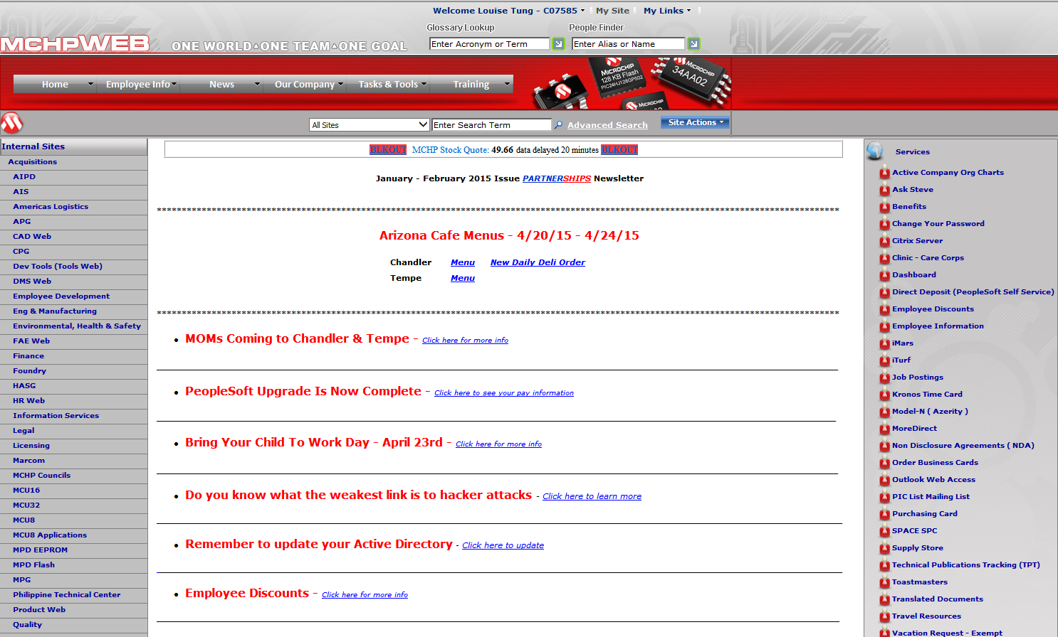

* There is no RSS Feed or any news on the homepage of the intranet
* Many of the links across the sides of the homepage can be found under the navigation bar on top
* As you can see the design is very basic, with lots of repetitive information and data even across the main screen

### Customer Demand

* **Appearance and navigation style:** provide a clean, consistent, stylish, and streamlined appearance and navigational structure that is easy for users to glance through the content and know where they are on the site. (Must have)
* **Content management:** identify content grouping, editorial/style guidelines, and ownership by dividing the home page into editing components and assigning designated user groups to the maintenance of their own components. (Nice to have)
* **Information searching and sharing:** create friendly search tools to facilitate information sharing and increase employee productivity.

1. Acronym glossary Wiki page: design and develop a friendly Wiki page for employees to search and contribute to the definition of Microchip specific acronyms. (Must have)
2. Conference room finder: design and develop a friendly search tool for displaying the location/map, room view, phone number, and capacity of a conference room. (Nice to have)

### 

### Initial Mock-ups & Designs

We actually provided multiple mock-ups to our client, and after our meeting with client, they chose the one below. Here we have the basic initial drawings & mockups done prior to the actual designing of the intranet

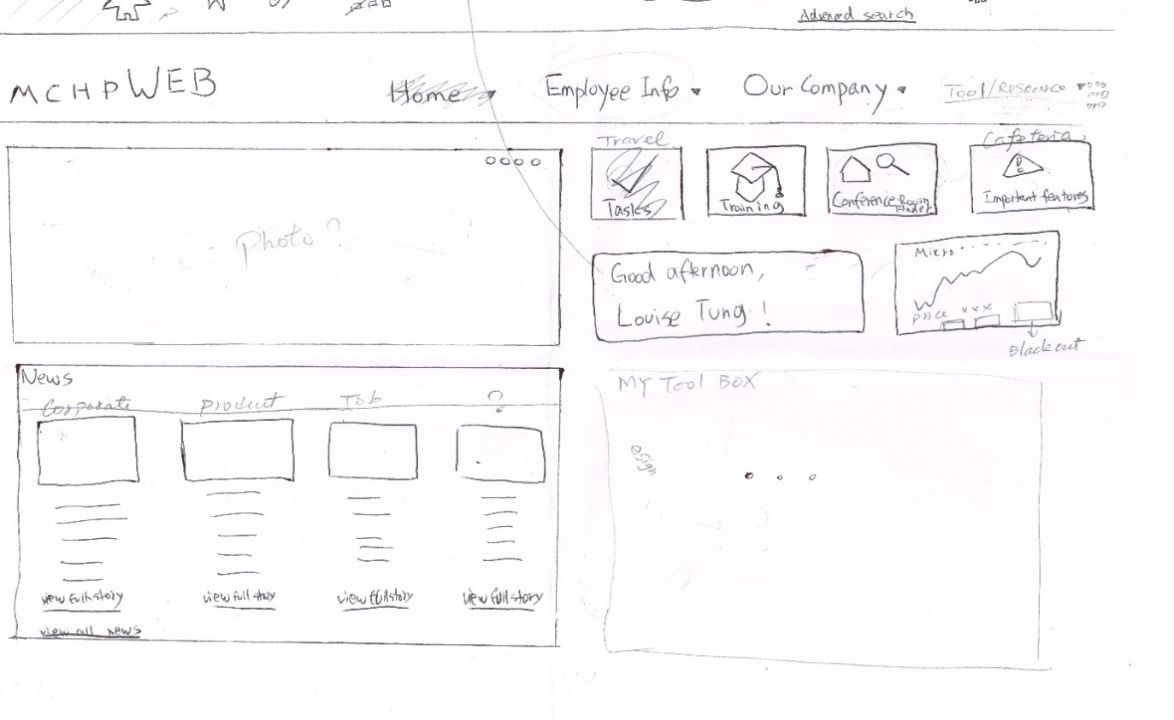

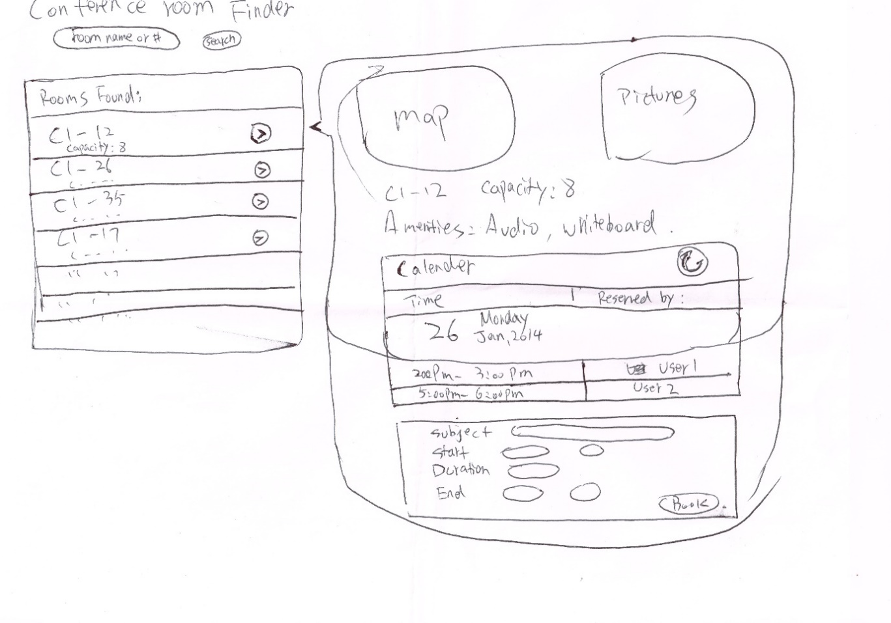

### Initial Mock-ups & Designs (cont.)

* Here we have a more in-depth mock-up of the intranet design drawn through Balsamiq software

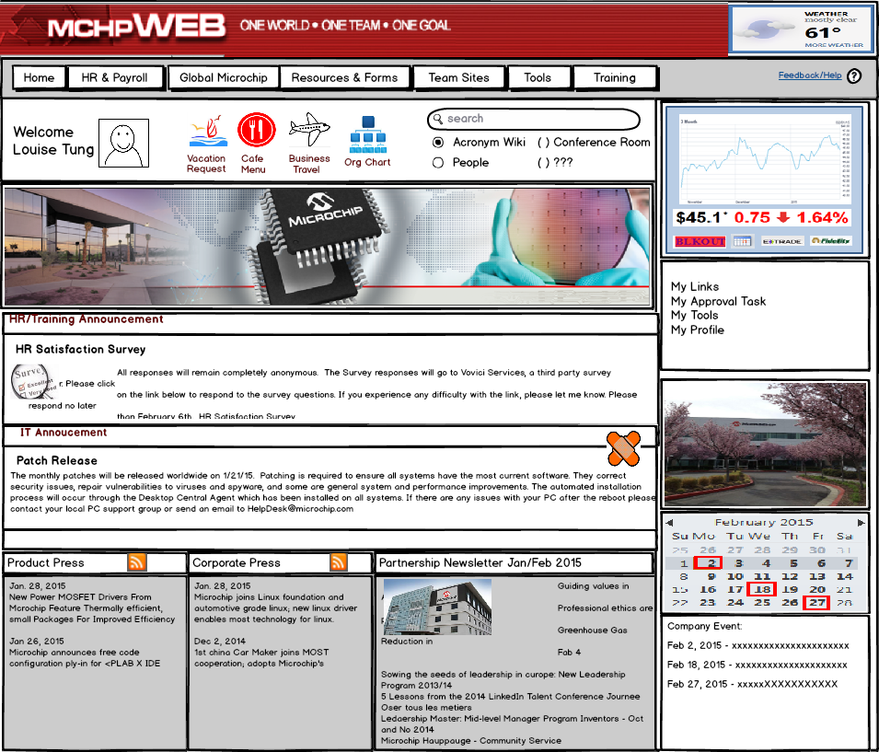

* We have eliminated much of the repetitive information, we added the RSS feed at the bottom for important internal company news and overall cleaned up the design and we moved forward with the actual design based on this mock-up

### Meetings and Changes

Throughout the whole semester, we generally meet with our client weekly. Each time, we provide some progress compare to last meeting, and also, set the goal for next meeting. And here is the meeting schedule and meeting information:

* Jan. 21: Meeting w/ Louise, form the team, get brief introduce from Microchip
* Jan. 26: Meeting w/ Louise, show our drawing mockups, set time for next meeting, and goal
* Feb. 04: Meeting w/ Louise, get a simple mockup, shows the webpage, and get more files for webpage
* Feb. 11: Meeting w/ Louise, determined tools to be used to develop intranet. Set development environment accounts
* Feb. 25: Meeting w/ Louise, test dummy setup pages, determine metadata for database for the conference room finder and wiki acronym search
* Mar 11: Meeting w/ Louise, Test MicroWiki, create acronyms in MicroWiki, talk about implementing world clock
* Mar 24-25: Get feedback from Louise via email, feedback on WorldClock, enhanced conference room finder
* Apr 1: Meeting with Louise. Generated excel test document with Louise

Here is the time and goal we set at the beginning of the project:

Release 0.1 – Jan 29: Create mockups for

* Mchpweb Intranet site: determine template layout, look/feel style
* Acronym wiki page: page layout and features
* Conference room finder: page layout and features

Release 0.2 – Feb 12:

* Determine tools to be used for the home page, wiki page, and conference room finder
* Set up accounts and development environment
* List Intranet home page components and groupings

Release 0.3 – Feb 26:

* Create unpolished Mchpweb home page, wiki, and room finder
* Gather sample data for home page components, acronyms, and conference room listing/info, map

Release 0.4 – Mar 12: Create a Youtube video

Release 0.5 – Mar 26:

* Features demo
* Determine components to keep for the final product

Release 0.6 – Apr 9:

* Test and bug fix
* Documentation
* Determine and create test cases
* Run automated test cases (what type of automated test tool?)

Release 1.0 – Apr 28: Final product demo

* Final demo and report documentation

Home page components –

• Stock: get from NSDAQ real-time + links to ETrade and Fidelity

• Company news: Communication meeting, Partnership Newsletter, corporate/product headlines

• Department sites: AIPD, …

• Service Tools: eSign, conference room finder, change my password, VR, etc.

• Employee Information: Corporate, HR, Training, Finance/Purchasing, Legal, IT, Site Service

Compare to the initial mock-ups, our final product has some improvement and changes.

* The position of weather and my links switched
* Search panel has been moved to top right
* We add world clock to sitemap
* Add zoom-in function to conference room finder
* Microwiki now have to login to create, edit, or delete
* Other Minor changes

### User Guide

Note: User Guide will explain and take the user step-by-step on how to use the key functionalities that were required for the project

Functionalities Include:

* Navigating/Using the Micro Wiki Acronym Tool
* Navigating/Using the Conference Room Finder
* Navigating/Using the World Clock

**Main Page**: From this page the user is able to navigate to the MicroWiki, The conference room finder & the world clock.

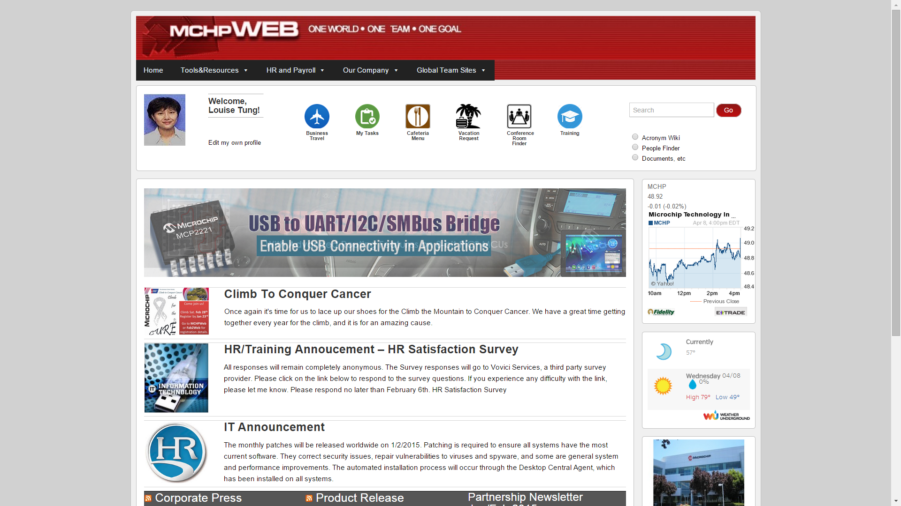

##### **Conference Room Finder:**

Step 1: To access the CRF, from the Home Page click on the Conference room finder icon in the icon ribbon left of the search bar on the top right hand corner.

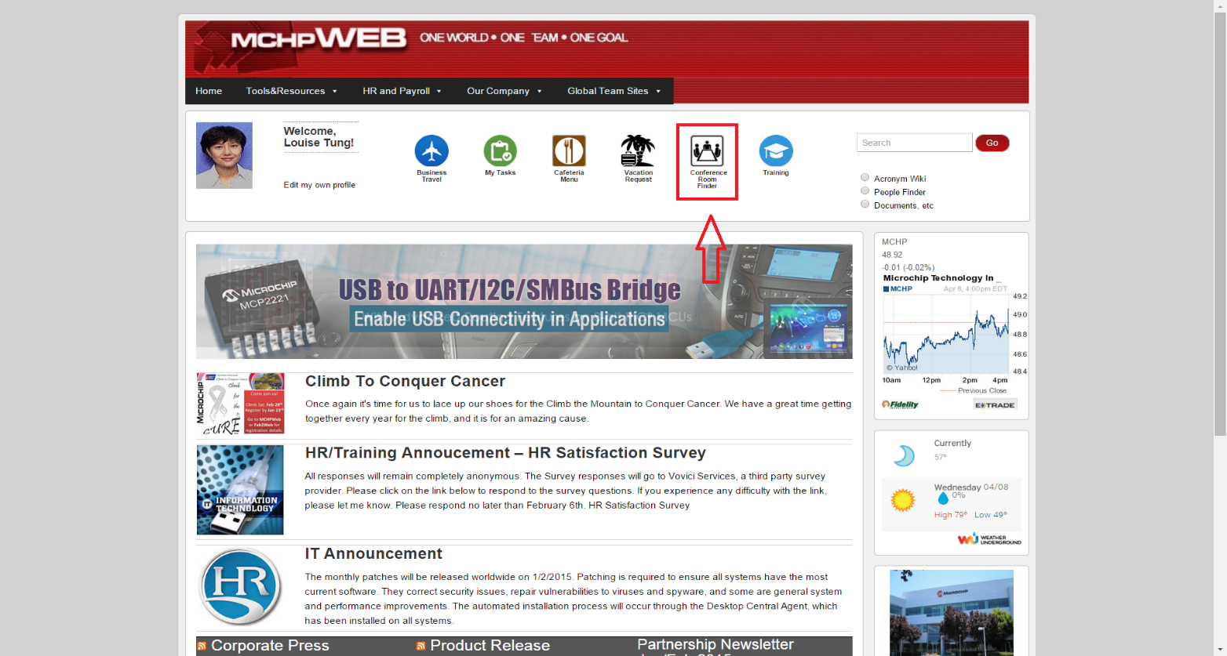

Step 2: Once you arrive on the conference room finder page like the one below, on the search bar below (not the search bar on the top right hand corner), please enter the conference room you will like to search.

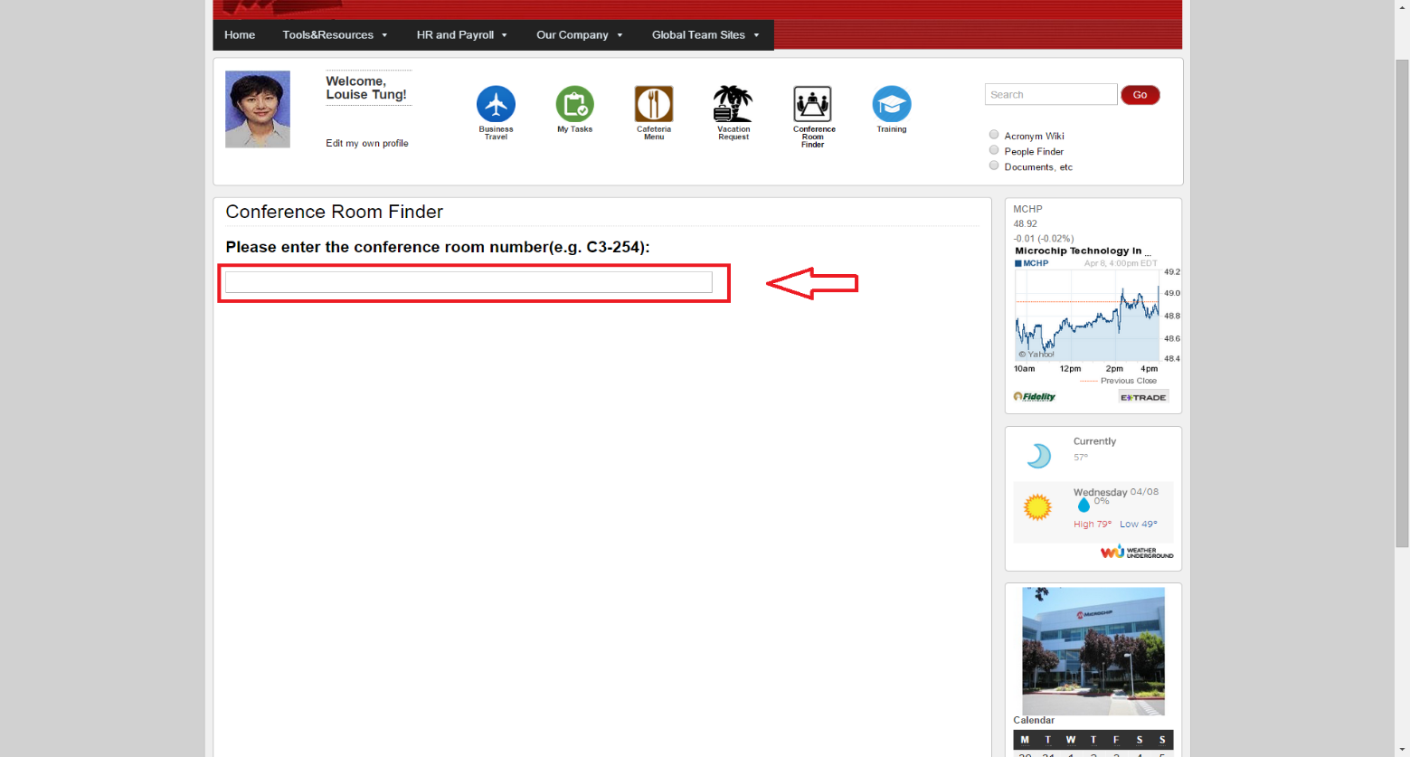

Step 3: Once you enter the first couple of letters of the conference room, it will show a recommended list, which you can choose from and once you have chosen a conference room, it will show a map of where the conference room is located like the picture below.

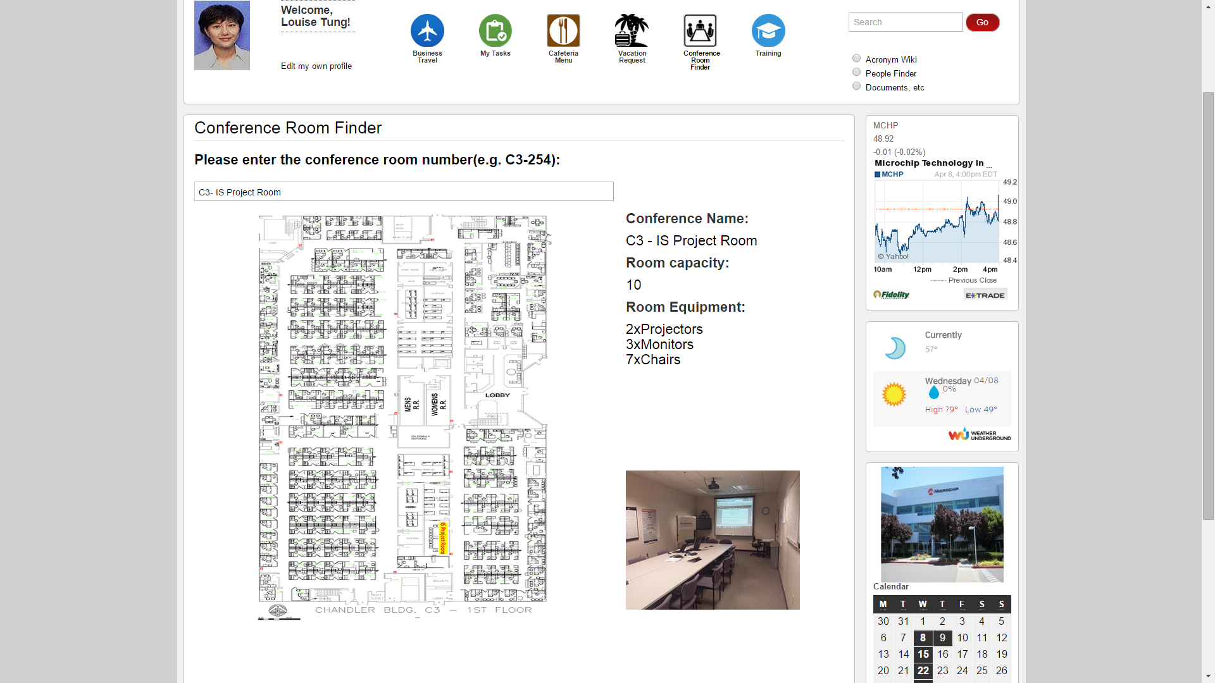

##### **MicroWiki Page:**

Step 1: To access the MicroWiki Page, from the main home page please click the Tools & Resources tab from the tool bar at the top of the page, which will drop down a menu; and from there please select “Acronym Wiki” right below conference room finder under the “Finder” sub menu.

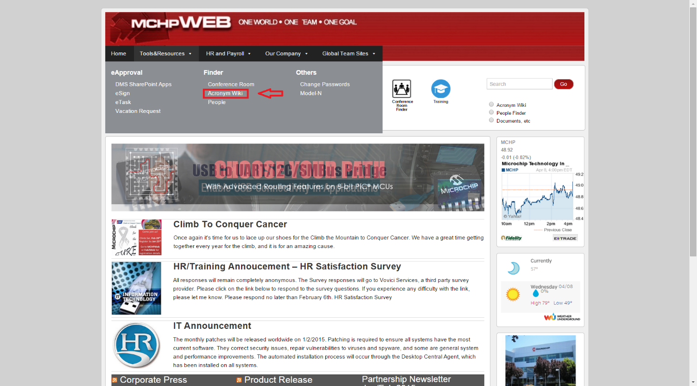

Step 2: Once you click “Acronym Wiki” you will be taken to the MicroWiki page which looks like this

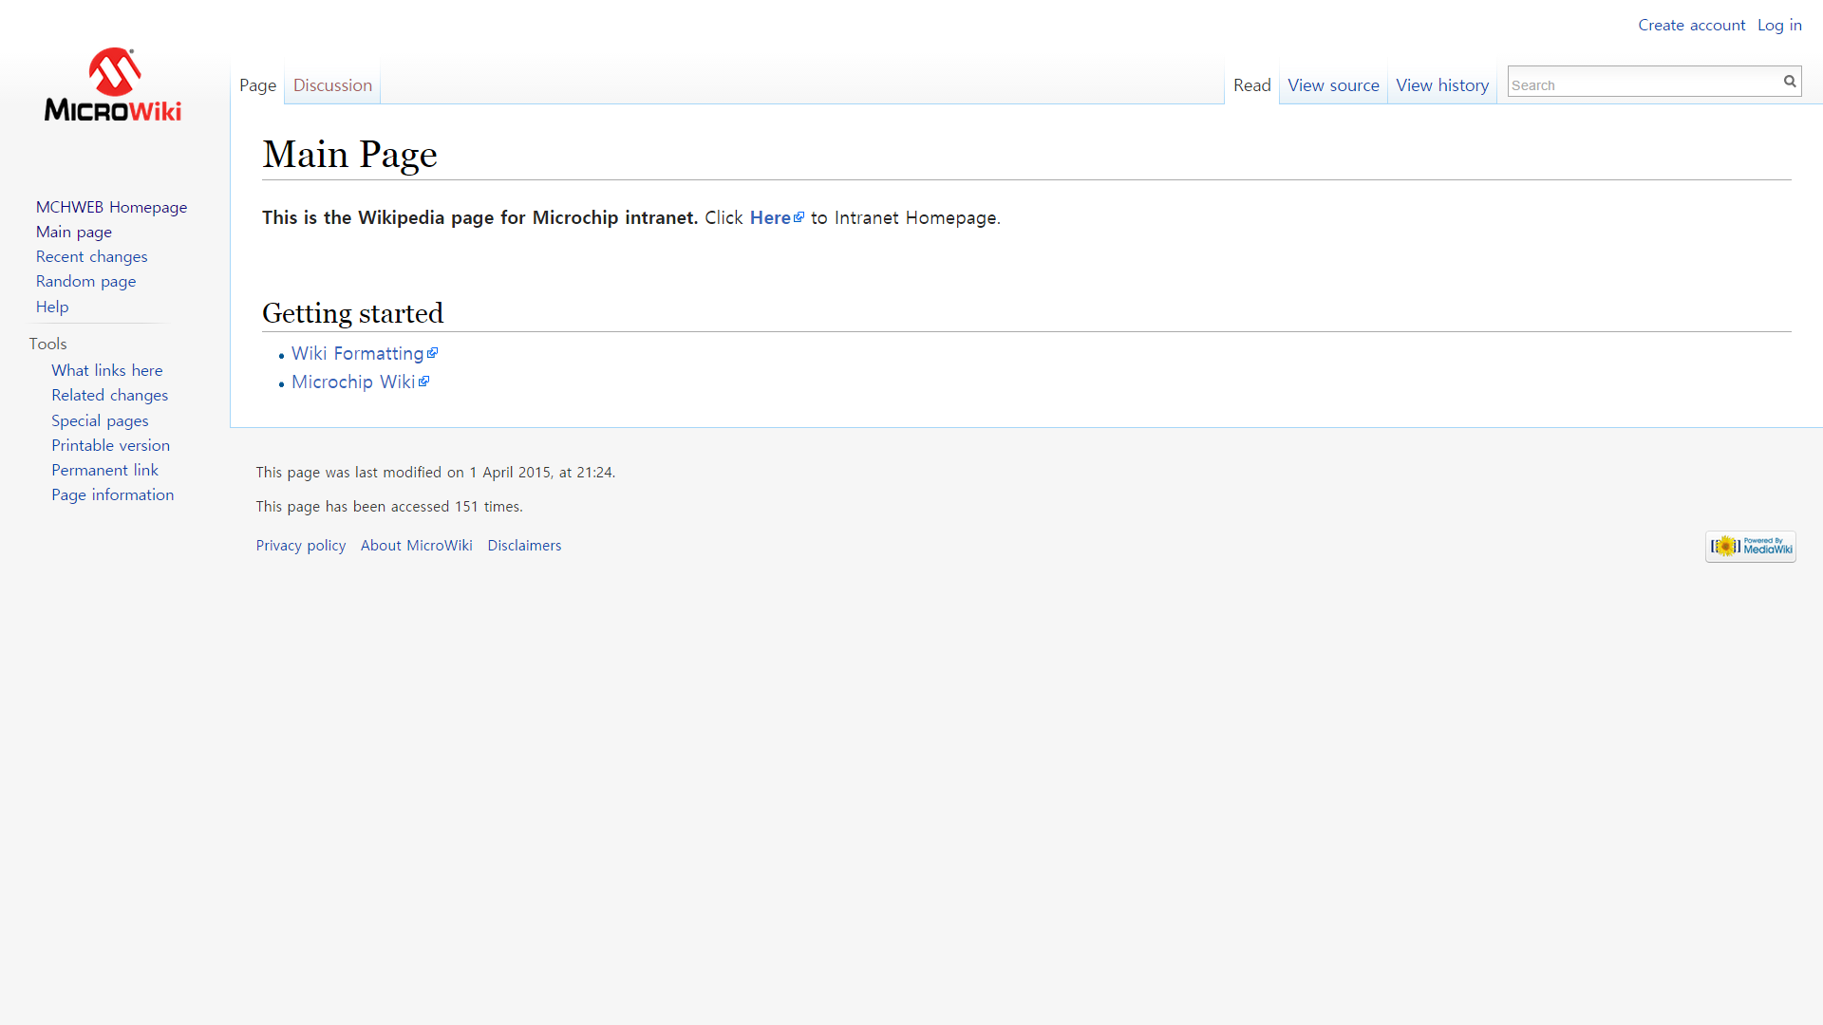

Step 3: From the MicroWiki Page user may now search or add an acronym. First to search type in the acronym you would like to search in the search bar in the top right hand corner just like Wikipedia.

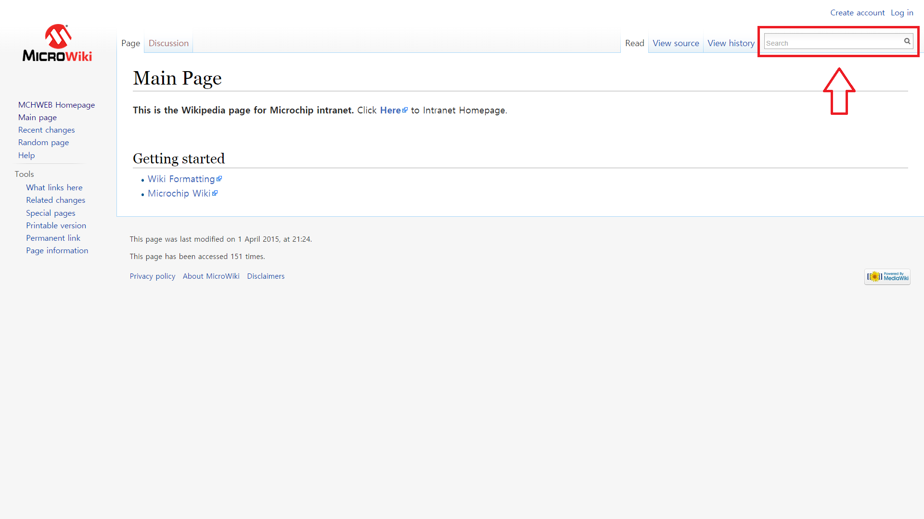

Step 4: Once you search word E.G: “DOS” you will be taken to a page which explains and defines the acronym.

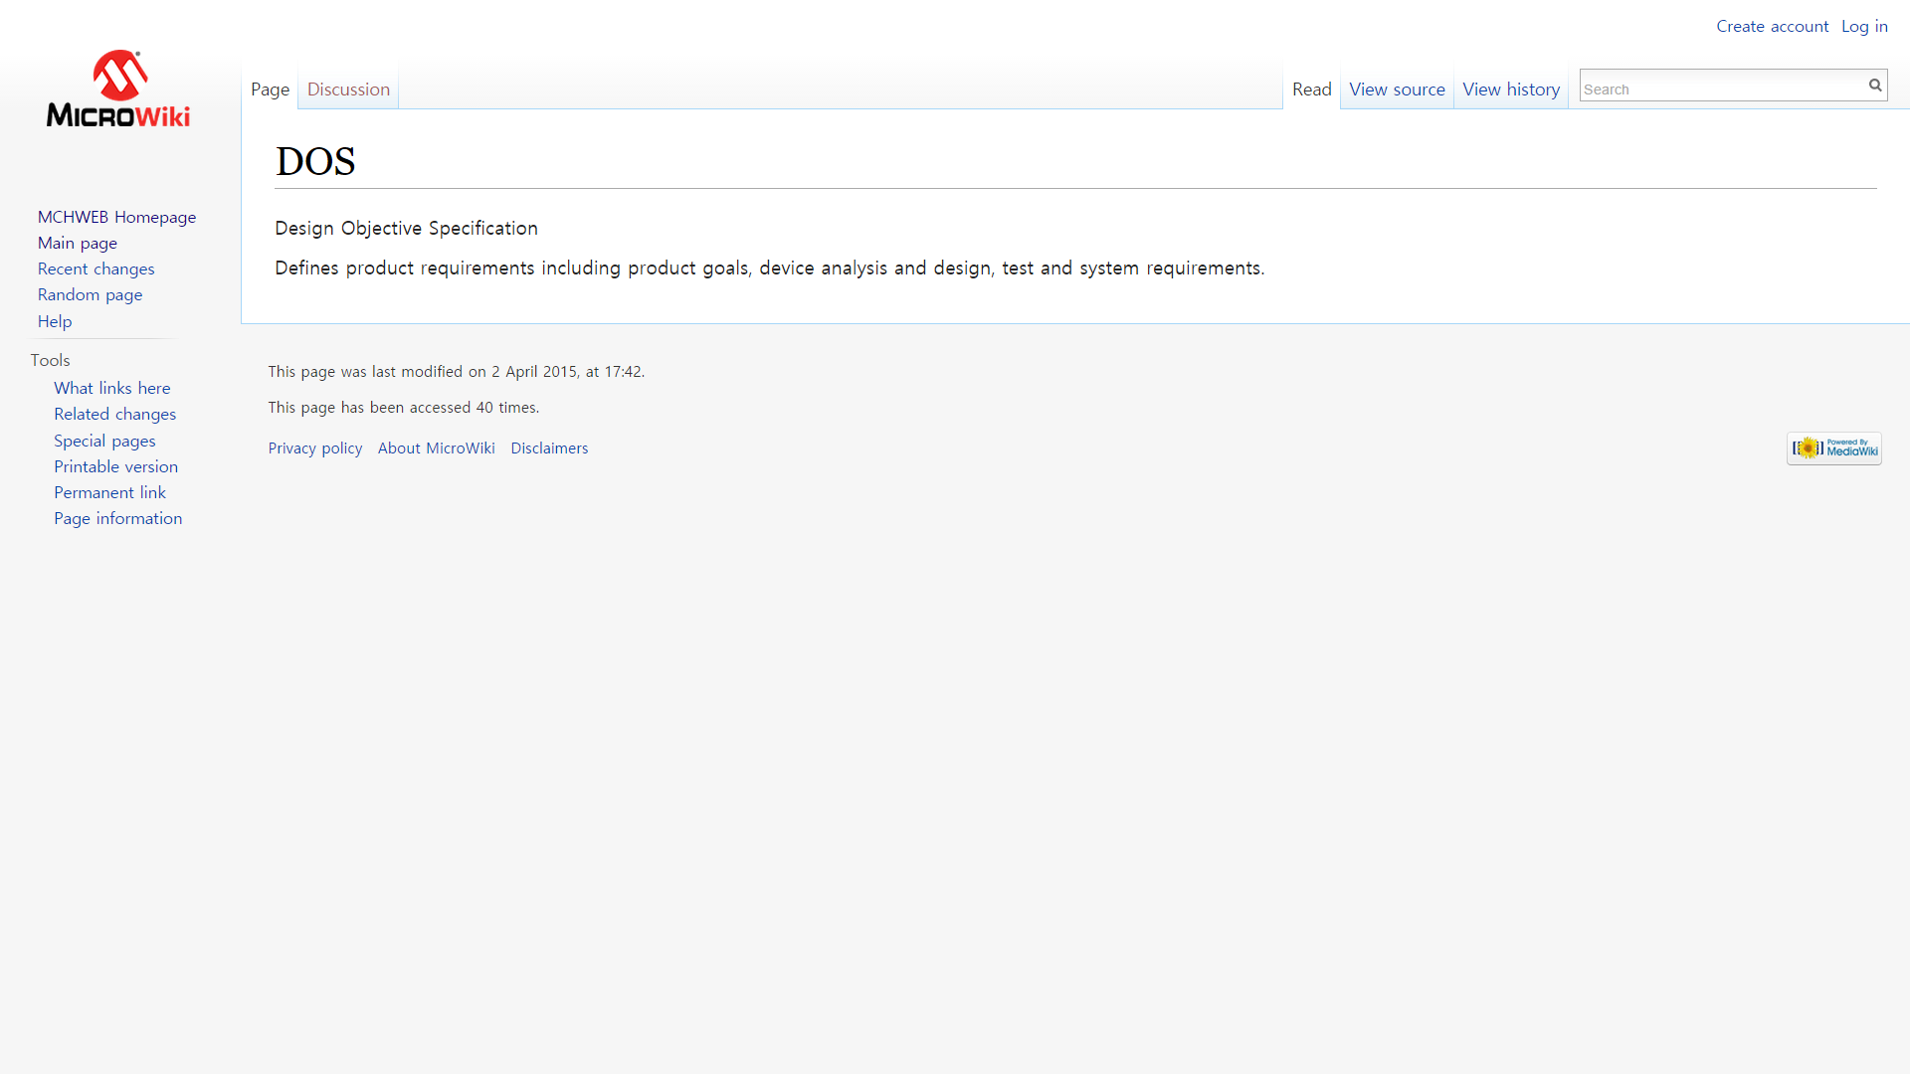

Step 5: Now to create a new acronym, the user must first log in or create an account with the MicroWiki Page:

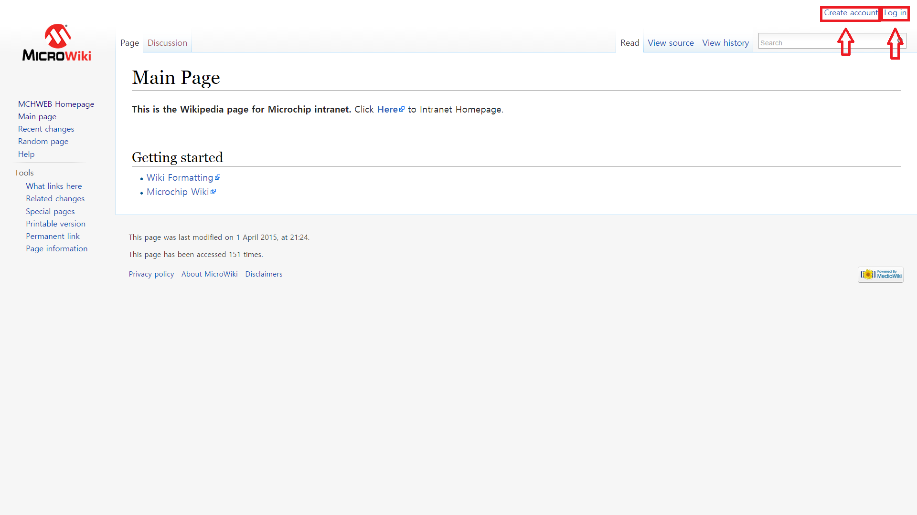

Step 6: Once you are logged in, the user is now given the right to add acronyms to the page, in order to do so the user must first search the acronym they wish to add

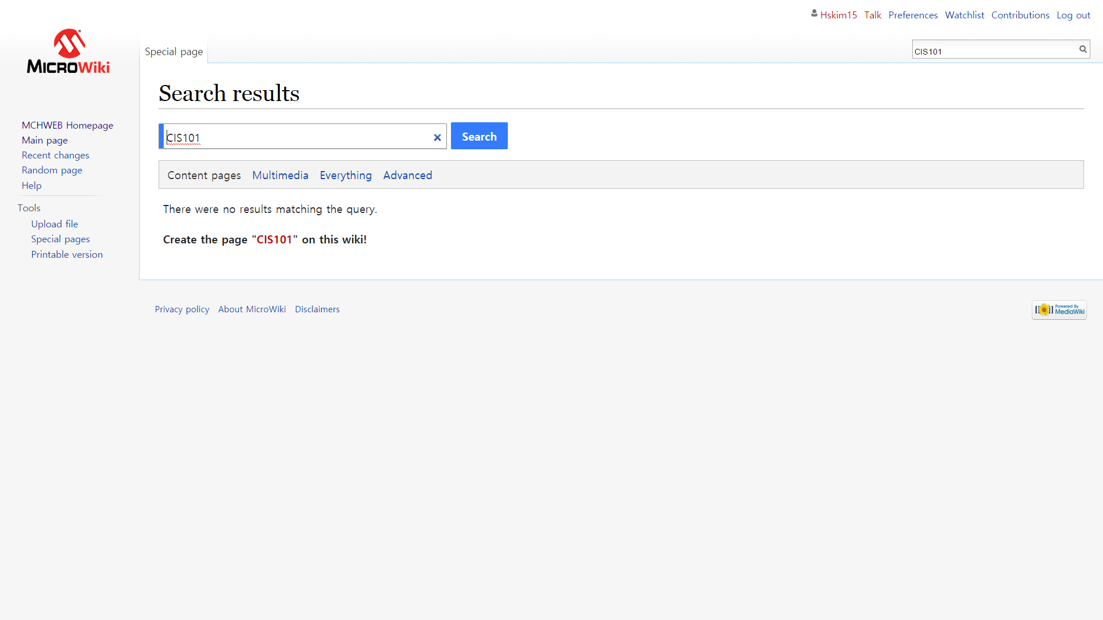

Step 7: Since the acronym does not yet exist in the wiki page, it will state that there were no results matching that query, and below it will state Create the Page “Acronym” on this wiki, you have to click the acronym within the quotations which will take you to a page where you can create a page for the specific acronym.

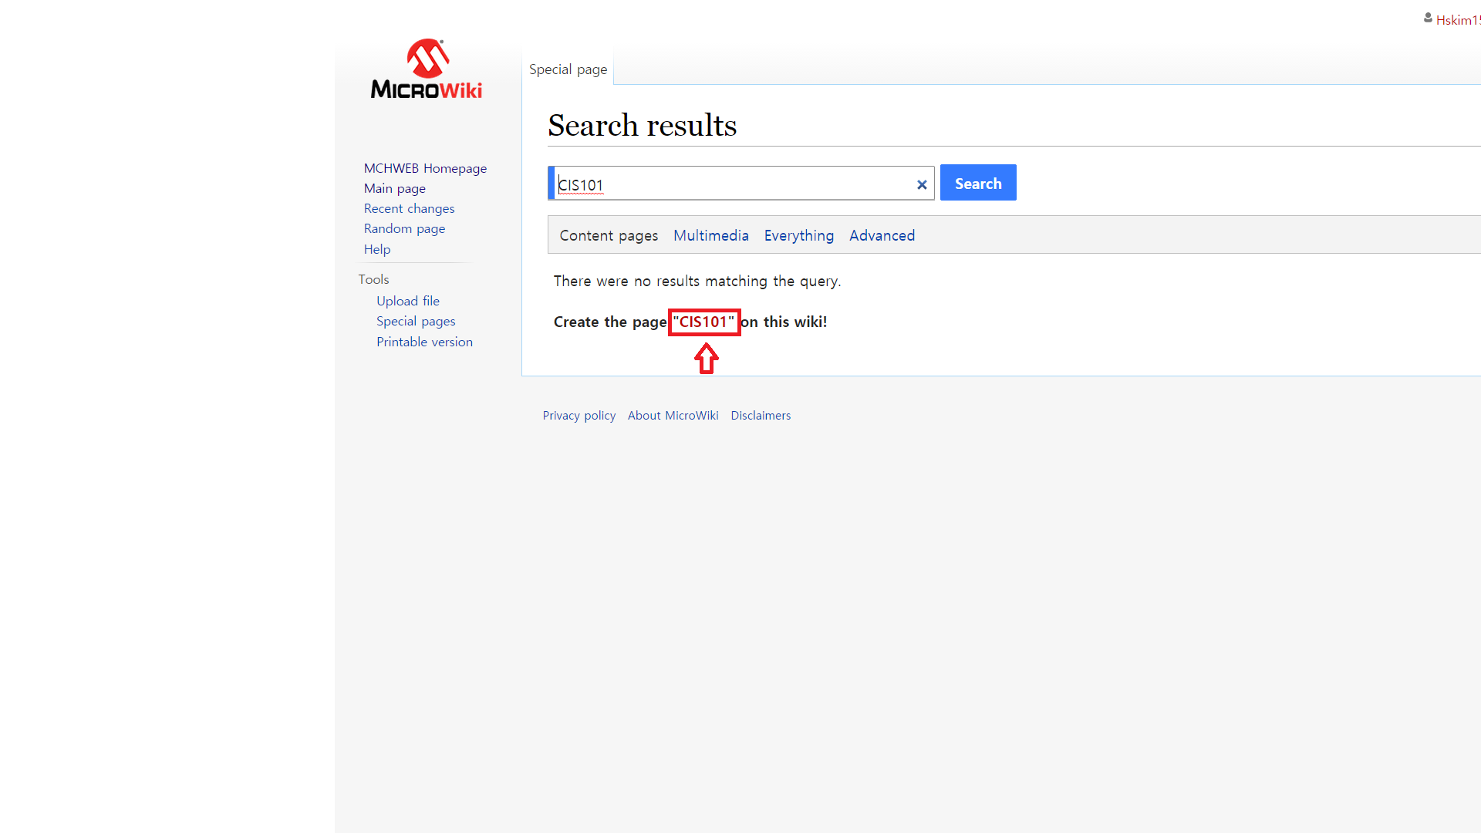

Step 8: Once you click on that acronym, it will take you to the page below, where the user can enter in the definition and explanation for that acronym

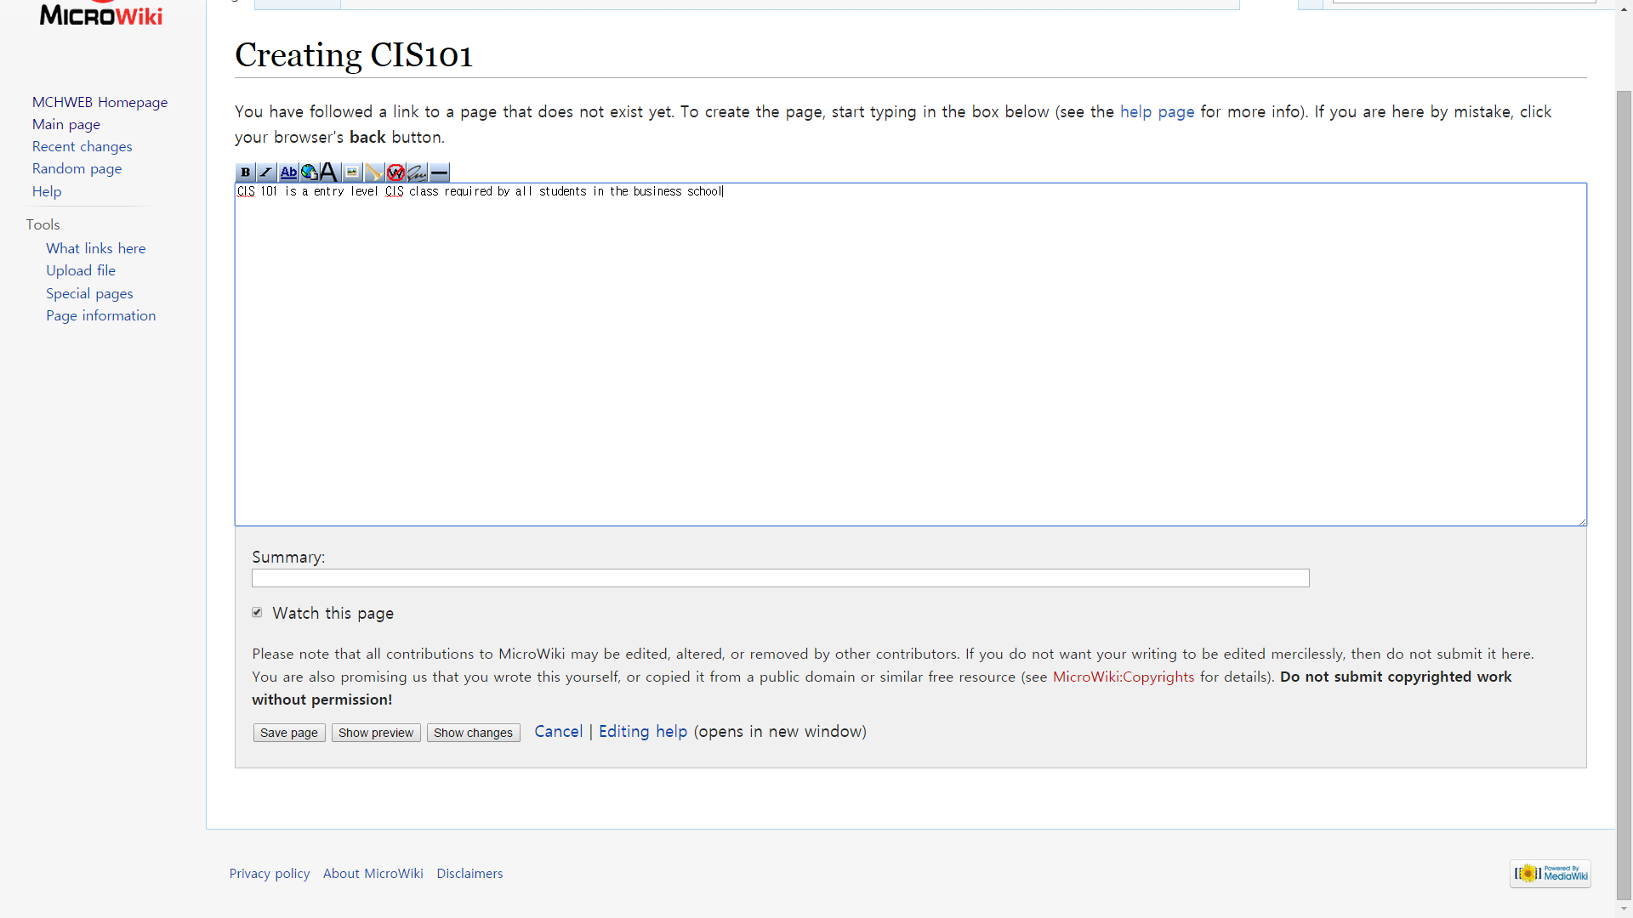

Step 9: Once you enter in the body information about the acronym, you will now hit the save page button on the bottom

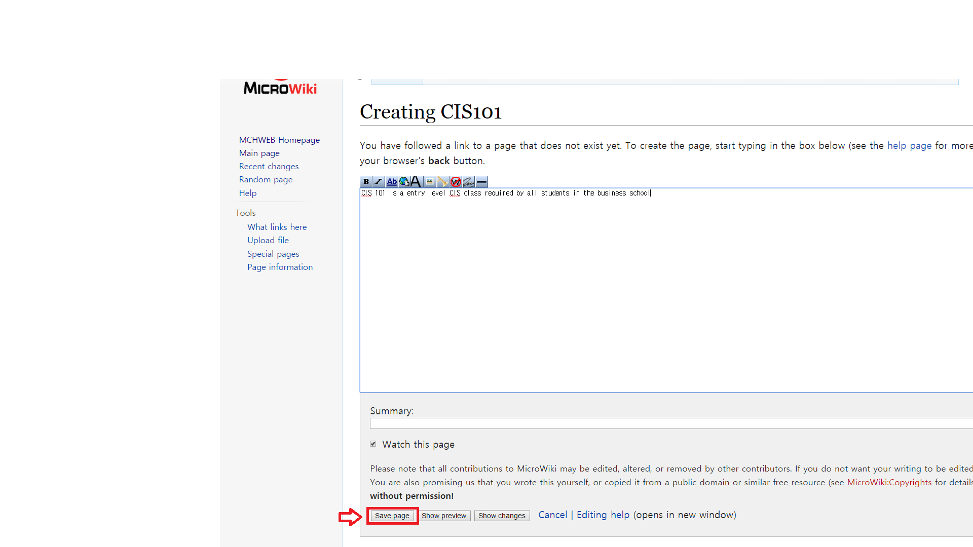

Step 10: Now once you hit Save Page button, you will be taken to the page for that new created acronym which is now searchable via the search bar on the Microwiki page.

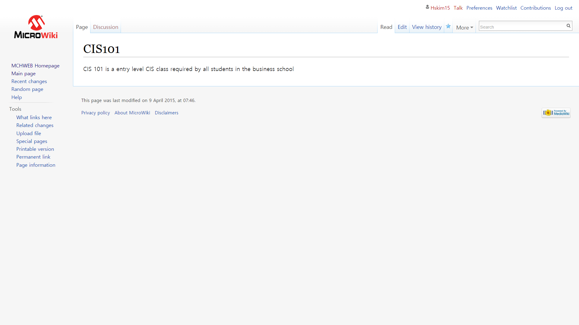

##### **World Clock:**

Step 1: To access the world clock, from the main page please select “Our Company” from the navigation bar on the top of the page and select “World Clock”

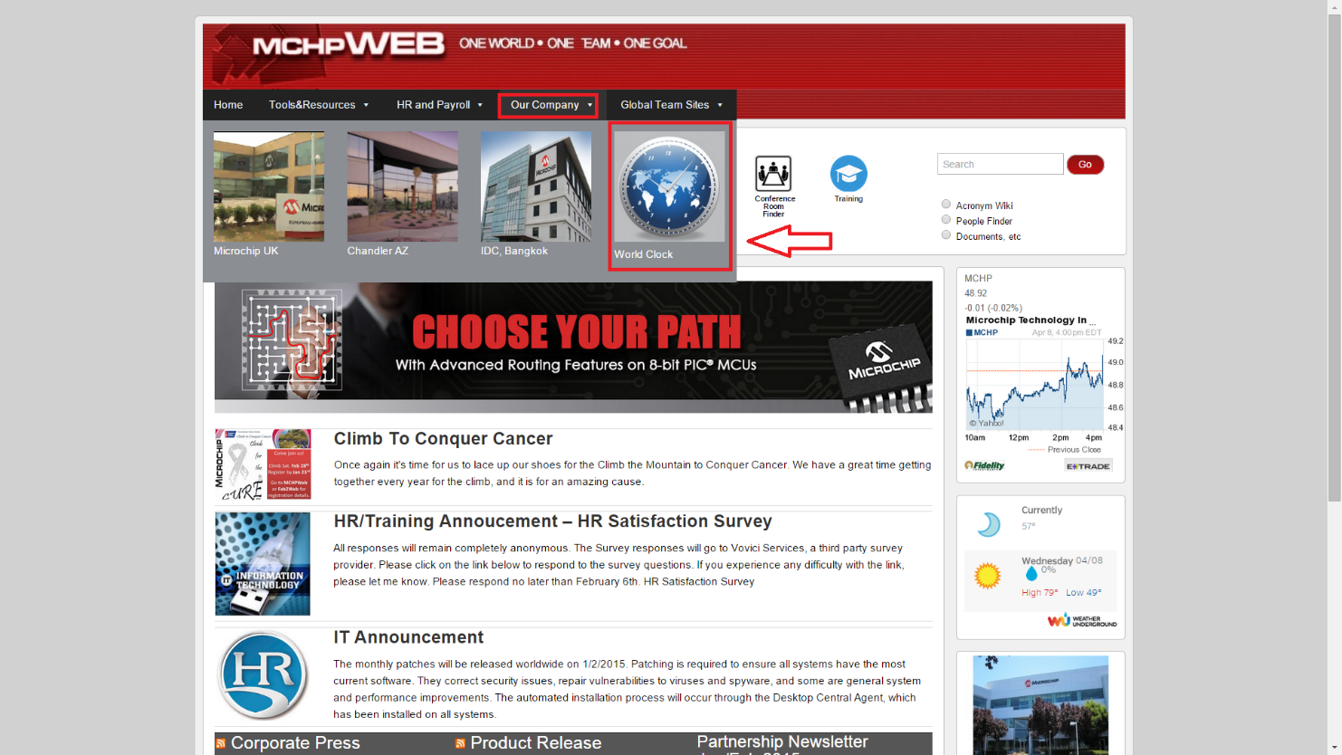

Step 2: Once you select “World Clock” it will take you to the World Clock Page, where it will show the time zones and other MicroChip locations around the world.

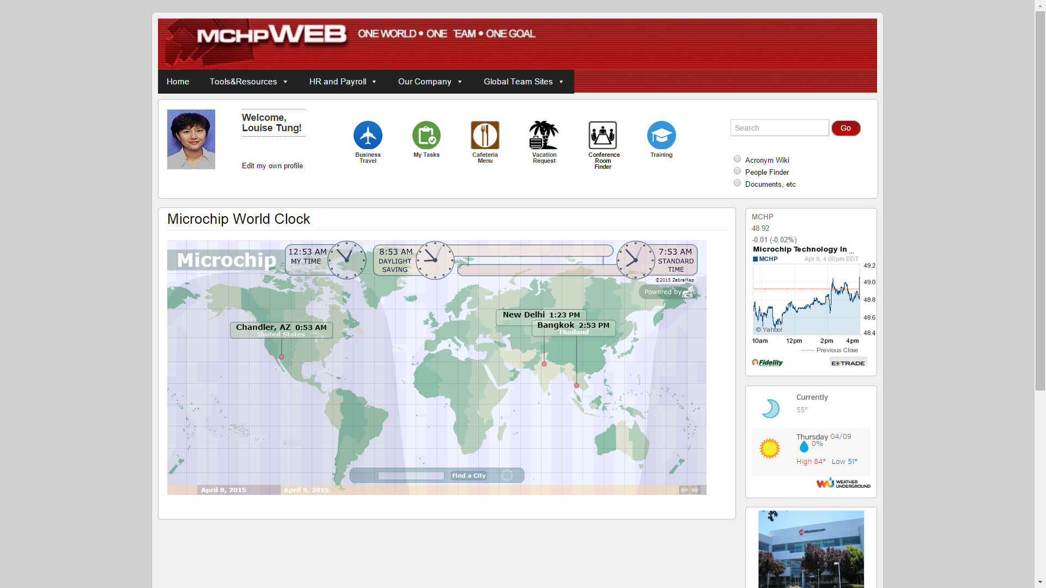

### Code View

Microwiki:

<?php

# This file was automatically generated by the MediaWiki 1.24.1

# installer. If you make manual changes, please keep track in case you

# need to recreate them later.

#

# See includes/DefaultSettings.php for all configurable settings

# and their default values, but don't forget to make changes in _this_

# file, not there.

#

# Further documentation for configuration settings may be found at:

# https://www.mediawiki.org/wiki/Manual:Configuration_settings

# Protect against web entry

**if** ( !defined( 'MEDIAWIKI' ) ) {

**exit**;

}

## Uncomment this to disable output compression

# $wgDisableOutputCompression = true;

$wgSitename = "MicroWiki";

## The URL base path to the directory containing the wiki;

## defaults for all runtime URL paths are based off of this.

## For more information on customizing the URLs

## (like /w/index.php/Page_title to /wiki/Page_title) please see:

## https://www.mediawiki.org/wiki/Manual:Short_URL

$wgScriptPath = "/microwiki";

$wgScriptExtension = ".php";

## The protocol and server name to use in fully-qualified URLs

$wgServer = "http://www.maxsong.us";

## The relative URL path to the skins directory

$wgStylePath = "**$wgScriptPath**/skins";

## The relative URL path to the logo. Make sure you change this from the default,

## or else you'll overwrite your logo when you upgrade!

$wgLogo = "**$wgScriptPath**/resources/assets/Microwiki.png";

## UPO means: this is also a user preference option

$wgEnableEmail = **true**;

$wgEnableUserEmail = **true**; # UPO

$wgEmergencyContact = "apache@www.maxsong.us";

$wgPasswordSender = "apache@www.maxsong.us";

$wgEnotifUserTalk = **false**; # UPO

$wgEnotifWatchlist = **false**; # UPO

$wgEmailAuthentication = **true**;

## Database settings

$wgDBtype = "mysql";

$wgDBserver = "localhost";

$wgDBname = "microchip";

$wgDBuser = "szhang74";

$wgDBpassword = "cis425";

# MySQL specific settings

$wgDBprefix = "";

# MySQL table options to use during installation or update

$wgDBTableOptions = "ENGINE=InnoDB, DEFAULT CHARSET=utf8";

# Experimental charset support for MySQL 5.0.

$wgDBmysql5 = **true**;

## Shared memory settings

$wgMainCacheType = CACHE_NONE;

$wgMemCachedServers = **array**();

## To enable image uploads, make sure the 'images' directory

## is writable, then set this to true:

$wgEnableUploads = **true**;

$wgUseImageMagick = **true**;

$wgImageMagickConvertCommand = "/usr/bin/convert";

# InstantCommons allows wiki to use images from http://commons.wikimedia.org

$wgUseInstantCommons = **false**;

## If you use ImageMagick (or any other shell command) on a

## Linux server, this will need to be set to the name of an

## available UTF-8 locale

$wgShellLocale = "en_US.utf8";

## If you want to use image uploads under safe mode,

## create the directories images/archive, images/thumb and

## images/temp, and make them all writable. Then uncomment

## this, if it's not already uncommented:

#$wgHashedUploadDirectory = false;

## Set $wgCacheDirectory to a writable directory on the web server

## to make your wiki go slightly faster. The directory should not

## be publically accessible from the web.

#$wgCacheDirectory = "$IP/cache";

# Site language code, should be one of the list in ./languages/Names.php

$wgLanguageCode = "en";

$wgSecretKey = "8bdbf3d599f4696bf4dd006a34d4d63b518c3b14473769a3334e44742e9aa86f";

# Site upgrade key. Must be set to a string (default provided) to turn on the

# web installer while LocalSettings.php is in place

$wgUpgradeKey = "ffcd69651abd3bcf";

## For attaching licensing metadata to pages, and displaying an

## appropriate copyright notice / icon. GNU Free Documentation

## License and Creative Commons licenses are supported so far.

$wgRightsPage = ""; # Set to the title of a wiki page that describes your license/copyright

$wgRightsUrl = "";

$wgRightsText = "";

$wgRightsIcon = "";

# Path to the GNU diff3 utility. Used for conflict resolution.

$wgDiff3 = "/usr/bin/diff3";

## Default skin: you can change the default skin. Use the internal symbolic

## names, ie 'vector', 'monobook':

$wgDefaultSkin = "vector";

$wgGroupPermissions['group']['right'] = **true**;

$wgGroupPermissions['*']['edit'] = **false**;

$wgGroupPermissions['*']['createpage'] = **false**;

$wgGroupPermissions['user']['edit'] = **true**;

$wgGroupPermissions['user']['createpage'] = **true**;

# Enabled skins.

# The following skins were automatically enabled:

**require_once** "**$IP**/skins/CologneBlue/CologneBlue.php";

**require_once** "**$IP**/skins/Modern/Modern.php";

**require_once** "**$IP**/skins/MonoBook/MonoBook.php";

**require_once** "**$IP**/skins/Vector/Vector.php";

# End of automatically generated settings.

# Add more configuration options below.

**Conference Finder:**

<meta charset=**"utf-8"**>

<title>**Conference Room Autocomplete Search**</title>

<link rel=**"stylesheet"** href=**"http://www.maxsong.us/blog/wp-content/uploads/2015/02/jquery-ui.css"**>

<script src=**"http://www.maxsong.us/blog/wp-content/uploads/2015/02/jquery-1.11.2.js"**></script>

<script src=**"http://www.maxsong.us/blog/wp-content/uploads/2015/02/jquery-ui.js"**></script>

<script src=**"http://www.maxsong.us/blog/js/jquery.elevatezoom.js"**></script>

<link rel=**"stylesheet"** href=**"/resources/demos/style.css"**>

<style>

**#project-label {**

**display: block;**

**font-weight: bold;**

**margin-bottom: 1em;**

**font-size: 20px;**

**}**

**#project-icon {**

**visibility:hidden;**

**float: left;**

**margin-right: 16%;**

**position:relative;**

**height: 600px;**

**width: 600px;**

**top: 40px;**

**margin-bottom: 50px;**

**}**

**#project-img {**

**visibility:hidden;**

**float: right;**

**height: 200px;**

**width: 250px;**

**position:absolute;**

**margin-top: 415px;**

**margin-left:620px;**

**}**

**h3 {**

**font-size: 20px;**

**}**

**#project-description {**

**margin-bottom: 1.5em;**

**text-align: left;**

**position: relative;**

**left: 620px;**

**top: -645px;**

**margin: 10;**

**padding: 10;**

**}**

**.ui-autocomplete-input{**

**width: 63.5%;**

**position: relative;**

**top:-650px;**

**}**

</style>

<script>

$**(*function*()** **{**

***var*** projects **=** **[**

**{**

value**:** "C3- IS Project Room"**,**

label**:** "C3- IS Project Room"**,**

info**:** "short description for the room, is here"**,**

desc**:** "<h3>Conference Name:</h3>C3 - IS Project Room <br> <h3>Room capacity:</h3>10 <br> <h3>Room Equipment:</h3> 2xProjectors<br>3xMonitors<br>7xChairs <br>"**,**

icon**:** "C3-IS sm.png"**,**

img**:** "conf1.jpg"

**},**

**{**

value**:** "C3-254"**,**

label**:** "C3-254"**,**

info**:** "dummie info for C3-254"**,**

desc**:** "<h3>Conference Name:</h3>C3-254 <br> <h3>Room capacity:</h3>15 <br> <h3>Room Equipment:</h3> 5xMonitors<br>10xChairs <br> "**,**

icon**:** "C3-254 sm.png"**,**img**:** "conf2.jpg"

**},**

**{**

value**:** "C3-1"**,**

label**:** "C3-1"**,**

info**:** "make it short"**,**

desc**:** "<h4>Conference Name:</h3>C3-1<br> <h3>Room capacity:</h3>21 <br> <h3>Room Equipment:</h3> 5xProjectors<br>10xMonitors<br>15xChairs <br> "**,**

icon**:** "C3-254 sm.png"

**},**

**{**

value**:** "C3-2"**,**

label**:** "C3-2"**,**

info**:** "this is demo"**,**

desc**:** "<h3>Conference Name:</h3>C3-2 <br> <h3>Room capacity:</h3>5 <br> <h3>Room Equipment:</h3>None <br> <"**,**

icon**:** "C3-254 sm.png"

**},**

**{**

value**:** "C3-3"**,**

label**:** "C3-3"**,**

info**:** "demo room 123"**,**

desc**:** "<h3>Conference Name:</h3>C3-3<br> <h3>Room capacity:</h3>42 <br> <h3>Room Equipment:</h3> 5xProjectors<br>2xMonitors<br>15xChairs <br> "**,**

icon**:** "C3-254 sm.png"

**}**

**];**

$**(** "#project" **).**autocomplete**({**

minLength**:** 0**,**

source**:** projects**,**

focus**:** ***function*(** event**,** ui **)** **{**

$**(** "#project" **).**val**(** ui.item.label **);**

***return*** ***false*;**

**},**

select**:** ***function*(** event**,** ui **)** **{**

$**(** "#project" **).**val**(** ui.item.label **);**

$**(** "#project-id" **).**val**(** ui.item.value **);**

$**(** "#project-description" **).**html**(** ui.item.desc **);**

$**(** "#project-icon" **).**attr**(** "src"**,** "http://www.maxsong.us/blog/images/" **+** ui.item.icon **);**

$**(** "#project-img" **).**attr**(** "src"**,** "http://www.maxsong.us/blog/images/" **+** ui.item.img **);**

document.getElementById**(**"project-icon"**).**style.visibility **=** "visible"**;**

document.getElementById**(**"project-img"**).**style.visibility **=** "visible"**;**

document.getElementById**(**"project-icon"**).**style.height **=** "600px"**;**

document.getElementById**(**"project-icon"**).**style.width **=** "600px"**;**

***return*** ***false*;**

**}**

**})**

**.**autocomplete**(** "instance" **).**_renderItem **=** ***function*(** ul**,** item **)** **{**

***return*** $**(** "<li>" **)**

**.**append**(** "<a>" **+** item.label **+** " " **+** "</a>" **)**

**.**appendTo**(** ul **);**

**};**

**});**

</script>

<div id=**"project-label"**>**Please enter the conference room number(e.g. C3-254):**</div>

<img id=**"project-icon"** src=**""** data-zoom-image=**"http://www.maxsong.us/blog/images/C3-IS.png"** alt=**""** />

<img id=**"project-img"** src=**""** alt=**""** />

<input id=**"project"**>

<input type=**"hidden"** id=**"project-id"**>

<p id=**"project-description"**></p>

<script>

$**(**"#project-icon"**).**elevateZoom**({**

tint**:*true*,**

tintColour**:**'#888888'**,**

tintOpacity**:**0.5**});**

</script>

### Test Results

We use two different way to testing our webpage, automated and manual. We chose Selenium as the automation testing tool.

**Targeting Test**

Menu, Links, Wikipage, Login, Logout, Edit, Source View, ConferenceFinder, World Clock

**Manual Test**

The manual test is been done by real Microchip employee, David. It tested the completed website by Chrome.

**Automation Test**

The automation test is using Selenium as testing tool, and testing arrangement including buttons, navigation, conference finder, and microwiki. And the web browser is Firefox.

**Below are screenshots of both test and code examples:**

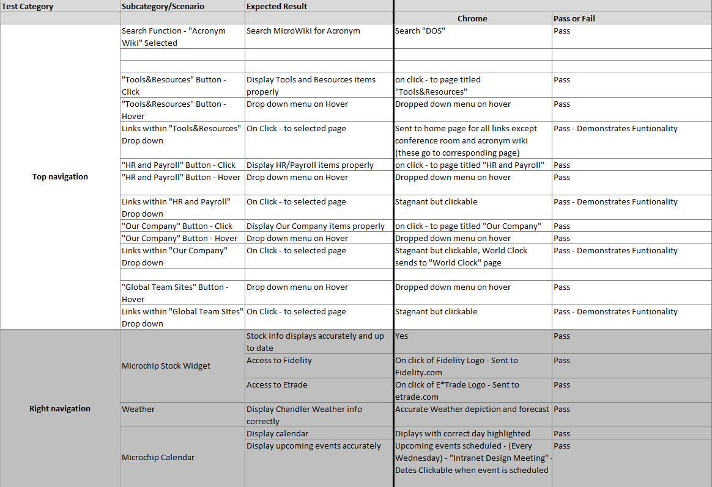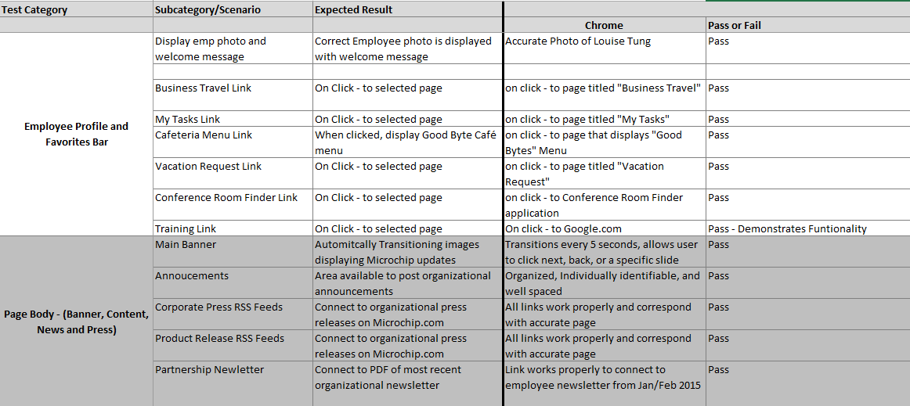

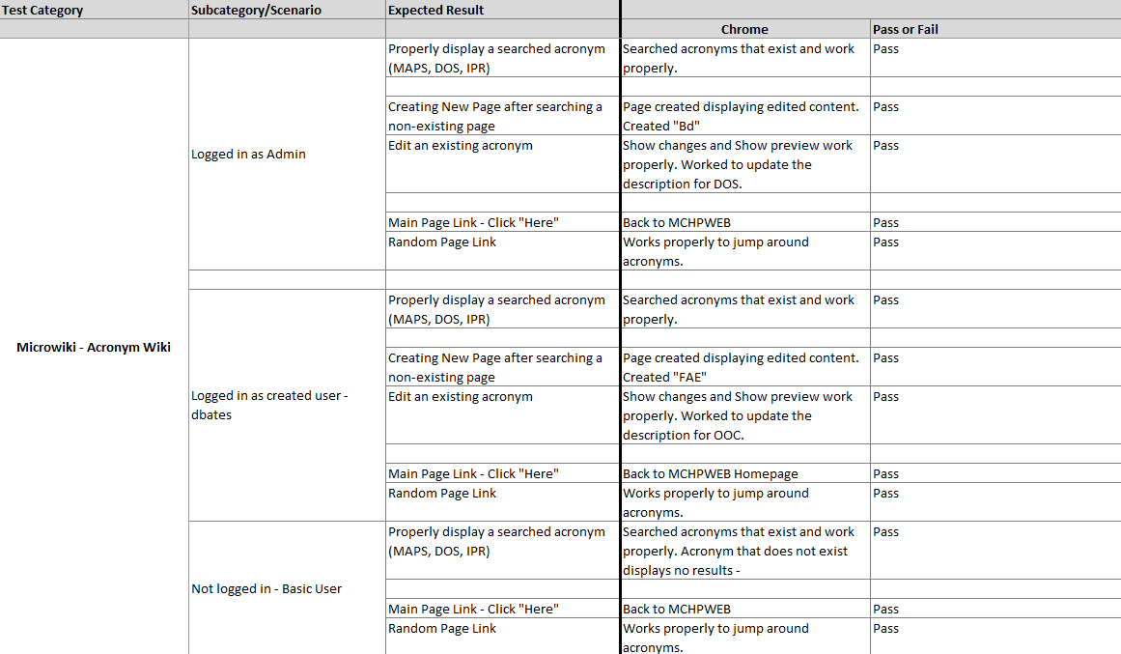

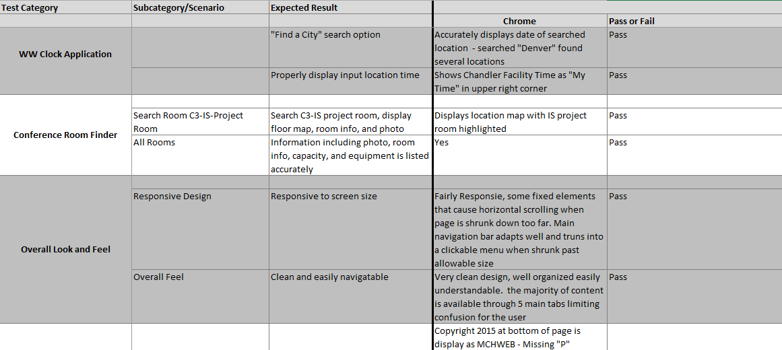

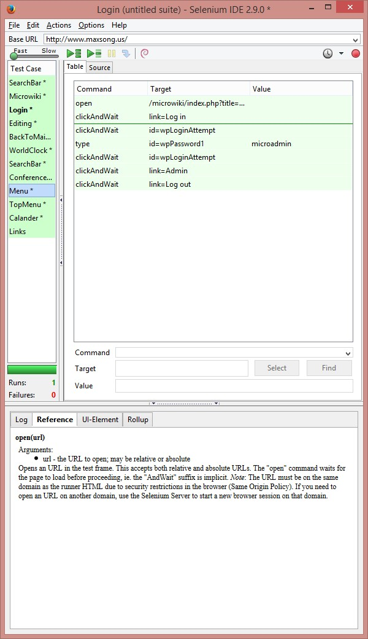

**Code Example to Automation Test**

**[**SetUp**]**

**public** void SetupTest**()**

**{**

driver **=** **new** FirefoxDriver**();**

baseURL **=** "http://www.maxsong.us/"**;**

verificationErrors **=** **new** StringBuilder**();**

**}**

**[**TearDown**]**

**public** void TeardownTest**()**

**{**

**try**

**{**

driver**.**Quit**();**

**}**

**catch** **(**Exception**)**

**{**

// Ignore errors if unable to close the browser

**}**

Assert**.**AreEqual**(**""**,** verificationErrors**.**ToString**());**

**}**

**[**Test**]**

**public** void TheLoginTest**()**

**{**

driver**.**Navigate**().**GoToUrl**(**baseURL **+** "/microwiki/index.php?title=Microwiki"**);**

driver**.**FindElement**(**By**.**LinkText**(**"Log in"**)).**Click**();**

driver**.**FindElement**(**By**.**Id**(**"wpLoginAttempt"**)).**Click**();**

driver**.**FindElement**(**By**.**Id**(**"wpPassword1"**)).**Clear**();**

driver**.**FindElement**(**By**.**Id**(**"wpPassword1"**)).**SendKeys**(**"microadmin"**);**

driver**.**FindElement**(**By**.**Id**(**"wpLoginAttempt"**)).**Click**();**

driver**.**FindElement**(**By**.**LinkText**(**"Admin"**)).**Click**();**

driver**.**FindElement**(**By**.**LinkText**(**"Log out"**)).**Click**();**

**}**

**private** bool IsElementPresent**(**By by**)**

**{**

**try**

**{**

driver**.**FindElement**(**by**);**

**return** **true;**

**}**

**catch** **(**NoSuchElementException**)**

**{**

**return** **false;**

**}**

**}**

**private** bool IsAlertPresent**()**

**{**

**try**

**{**

driver**.**SwitchTo**().**Alert**();**

**return** **true;**

**}**

**catch** **(**NoAlertPresentException**)**

**{**

**return** **false;**

**}**

**}**

**private** string CloseAlertAndGetItsText**()** **{**

**try** **{**

IAlert alert **=** driver**.**SwitchTo**().**Alert**();**

string alertText **=** alert**.**Text**;**

**if** **(**acceptNextAlert**)** **{**

alert**.**Accept**();**

**}** **else** **{**

alert**.**Dismiss**();**

**}**

**return** alertText**;**

**}** **finally** **{**

acceptNextAlert **=** **true;**

**}**

**}**

**}**

### Testing Results Summary

* Since we developed the intranet design in Chrome, most of the testing in the Chrome browser was successful and to our expectations, but in other browsers like Firefox and IE, some design features and functions did not meet or pass expectations, but overall our design met the needs of our client and we were able to finish all the “to-do” and most of the “nice-to-have” on time.

### Whats Next

* This design of the intranet will be used as a demo for their own redevelopment of the intranet so it will not go live, some design features and functionality may carry over but for the most part most of the work will not go live
* Because of the security issues, Microchip will develop their intranet on their own using our design